People
Leonid Brezhnev
George H.W. Bush
James E. (Jimmy) Carter
Ngo Dinh Diem
Gerald R. Ford
Mikhail Gorbachev
Ho Chi Minh
Ayatollah Khomeini
Lyndon B. Johnson
Richard M. Nixon
The Plumbers: E. Howard Hunt, G. Gordon Liddy, James McCord, et al
Ronald W. Reagan
Anwar Sadat

Events
Bombing of Army-Math Research Center at Sterling Hall, UW-Madison, August 1970
Camp David Accords, 1978
Dow Chemical Riots, 1967
End of the Soviet Union, 31 December 1991
Fall of the Berlin Wall, Fall 1989
Ford’s pardon of Nixon, August 1974
Gulf of Tonkin Incident, the attack on the U.S.S. Maddox, August 1964
Iran Hostage Crisis, Dec. 17, 1979-Jan. 20, 1981
My Lai Massacre, 1968
Nixon Resigns Presidency, 9 August 1974
Secret War in Laos and Cambodia, 1961-75
Tet Offensive, January 1968
Watergate break-in, Summer 1972 / Watergate cover-up, Summer 1972-August 1974

Terms
Carter Doctrine
Clean Air Act / Clean Water Act / Environmental Protection Agency & Superfund
Committee to Re-elect the President (CREEP)
Contras
Détente
Domino theory
Enemies List
“Evil Empire”
Glasnost
Iran-Contra Affair (Contragate)
Operation Rolling Thunder
Pentagon Papers (Daniel Ellsberg)
Silent Majority
stagflation
Strategic Arms Limitations Treaty (SALT)
Tonkin Gulf Resolution
Vietnamization

Places
Afghanistan My Lai, South Vietnam
Cambodia & Laos Nicaragua and rest of Central America
Hanoi, North Vietnam Southwest Asia / Middle East
Israel & Egypt Saigon, South Vietnam

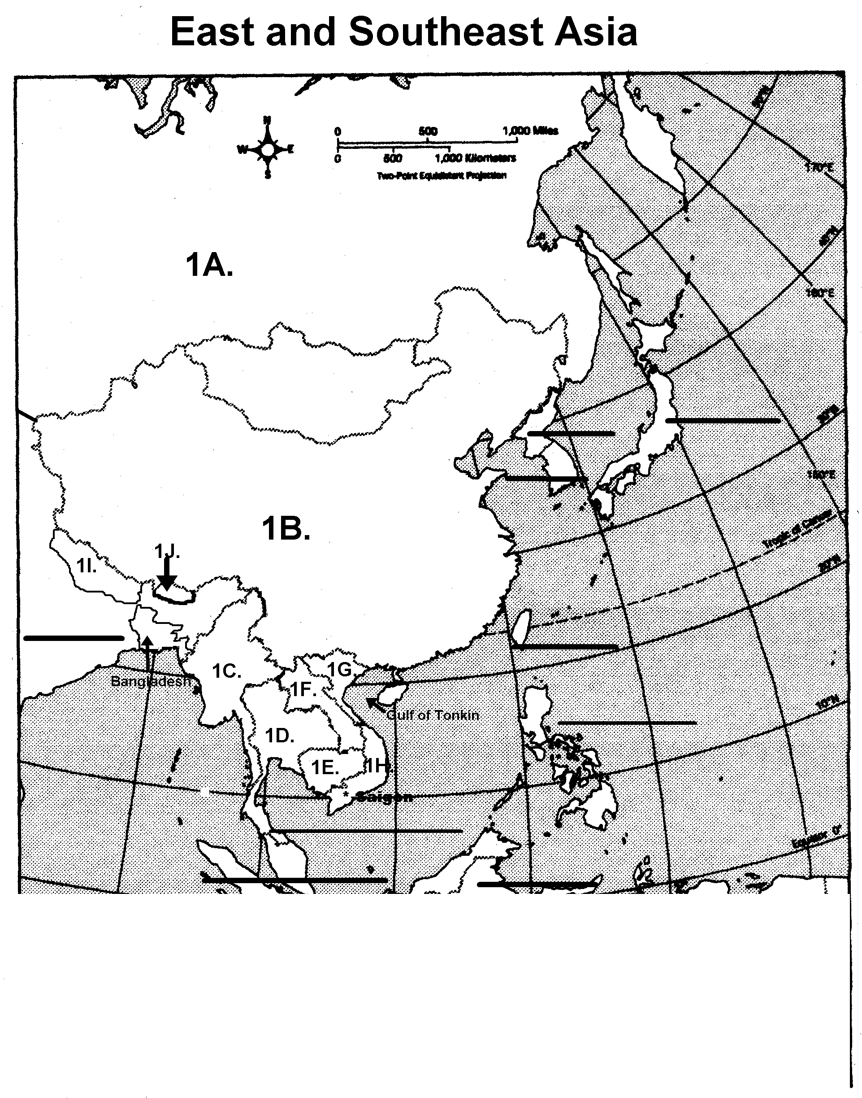

Map 1A. U.S.S.R. Map 1E. Cambodia / Kampuchea Map 1H. S.Vietnam
Map 1B. China Map 1F. Laos Map 1I. Nepal
Map 1C. Burma Map 1G. N. Vietnam Map 1J. Bhutan
Map 1D. Thailand

Southwest Asia / Middle East

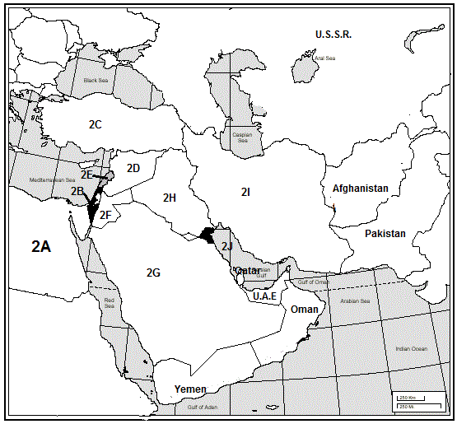

Map 2A. Egypt Map 2E. Lebanon Map 2H. Iraq
Map 2B. Israel Map 2F. Jordan Map 2I. Iran

Map 2C. Turkey Map 2G. Saudi Arabia Map 2J. Kuwait

Map 2D. Syria

